
Lesson Plan: Backwards Design
Name:
Mentor:
Grade Level/Subject Area: Date:

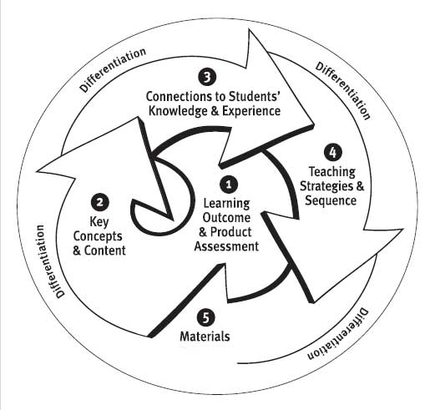
California Induction Program Standards
Check all that apply:
Standard 5: Pedagogy
Standard 6: Universal Access: Equity for All Students
Teaching English Learners
Teaching Special Populations

Lesson Topic: Content Standard:
Adopted Text(s): Supplemental Materials/Technology:
Note: Use the Essential Components of Differentiated Instruction in the FAS Resource section of your padfolio to help differentiate instructional strategies, content, products or assessments.
Learning Outcomes | Key Concepts & Essential Questions | Connections to Students' Knowledge, Skills, Experience
Learning Outcomes | Teaching Strategies & Sequence  Opening | Connections to Students' Knowledge, Skills, Experience
Evidence of Learning  (Product or Assessment) | Instruction | Connections to Students' Knowledge, Skills, Experience
Evidence of Learning  (Product or Assessment) | Instruction | Ways to differentiate instruction
Evidence of Learning  (Product or Assessment) | Guided Practice | Ways to differentiate instruction
Evidence of Learning  (Product or Assessment) | Closure | Ways to differentiate instruction
Evidence of Learning  (Product or Assessment) | Extension Activities or Independent Practice | Ways to differentiate instruction
Materials
Adapted from the work of Wiggins and McTigue.

